19CSE204

**BLOOD BANK MANAGEMENT SYSTEM**

**PROJECT REPORT**

**Group Members :**

**C P GHANSHYAM- AM.EN.U4CSE20118**

**DEVITHAA M DEEPAK- AM.EN.U4CSE20122**

**JOSHUA WILSON PHILIP- AM.EN.U4CSE20135**

horizontal line

# 

# ABSTRACT

Our Project ‘ **Blood Bank Management System’** is a computerized system used to store and retrieve information related to Blood donations/inventory.The aim of the project is to highlight the relevance and importance of Blood Bank Management Systems.

The system allows the admin/receptionist to store and retrieve information like blood donor details, blood receiver details, amount of blood present in the inventory of the blood bank store, etc.

The system checks for the availability of a certain blood type like A+, A-, B+, B- etc. If the blood type is available, then the system allows the admin to further proceed with the procedure. Otherwise, it asks the admin to choose another blood type.

The system asks the admin to enter customer details for further blood transactions. The main purpose of this software is to reduce the manual/paperwork involved in blood bank management and make it convenient for the admin/receptionist to store and retrieve data as and when required. The software supports the concept of modifications by admin and allows inserting, modifying, or deleting customer data.

**PURPOSE OF THE PROJECT**

This project is aimed to reduce the manual work involved in data maintenance in the Blood bank management system. This project is developed mainly to simplify the manual work and allow smooth administration of the operations of blood transactions.

The purpose of the project is to computerize the administrative operations of a blood transaction and to develop software that is user-friendly, simple, fast, and cost-effective. It deals with the collection of Donors, Receivers and Inventory information, etc. Traditionally, it was done manually. The main function of the system is to enter and retrieve these details as and when required, and also to manipulate these details meaningfully.

* To ease the process of blood donation and reception.
* To improve the existing traditional system.
* To develop a scalable system.
* To be highly efficient in system management.

**SCOPE**

● Ensure that all the functionalities of a manual blood bank are covered.

●To ensure proper contactable information.

● Make sure the program is simple and easy to use.

**CONNECTION**

1. **JSP**

Java Server Pages is a simple yet powerful technology for creating and maintaining dynamic-content web pages. It is based on the Java programming language. It can be thought of as an extension to Servlets because it provides more functionality than Servlets. A JSP page consists of HTML tags and JSP tags. The JSP pages are easier to maintain than Servlets because we can separate designing and development. We require a JDBC connection between the front end and back end components to write to the database and fetch the required data.

1. **PostgreSQL (BACKEND)**

PostgreSQL is a powerful, open-source object-relational database system with over 30 years of active development that has earned it a strong reputation for reliability, feature robustness, and performance.

**Functional Requirements of the System**

The functional requirements of this project are:

The project allows login of Admin :

The Admin has a set of functionalities described as:

> Can log in to the system.

> Can log out from his current account.

> Can add/delete or modify Donors in the database.

> Can add/delete or modify Receivers in the database.

> Can add/delete or modify Doctors in the database.

> Can add/delete or modify Inventory in the database.

**CLASS DIAGRAM**

A **class diagram** in UML is a type of static structure diagram that describes the structure of a system by showing the system’s classes, their attributes, operations(or methods), and the relationships among objects.

Classes are included in the following diagram:

* Admin
* Donor
* Organization
* Receiver
* Hospital

**Actors**

* Admin:A person who can access to all the computer system and can control by identifying and authenticate the user.Admin can add,update or delete the user,city,state etc
* Donor:A donor is a pearson who donates his blood to the blood bank organization.
* Hospital: Hospital is the place where the blood collected is transfused to the patients.
* Organization:A place where blood is collected and stored and preserved for later use in blood transfusion.
* Receiver:A receiver is a person who needs blood from the Donor

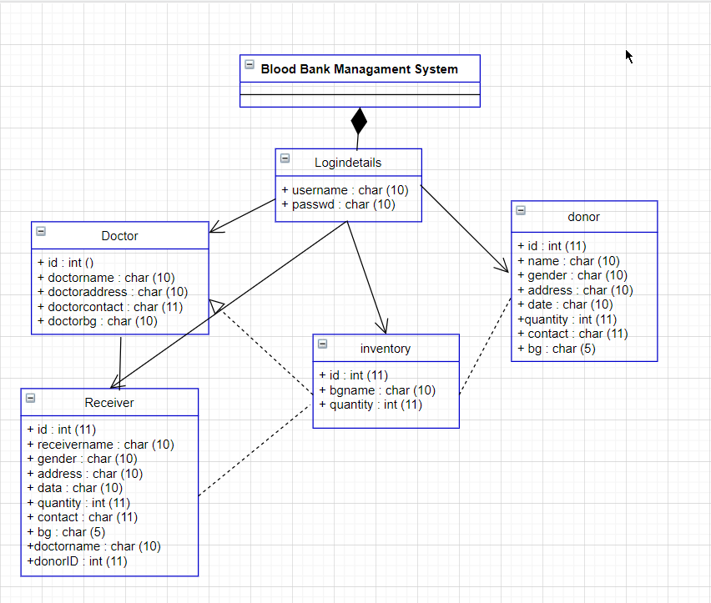

**USE CASE DIAGRAM**A **Use Case Diagram** is a representation of a user’s interaction with the system.

Cases are included in the following use-case diagram:

* Donation camp
* Reception table
* Donate blood
* Store blood
* Order blood
* Purchase blood

| **Use Case ID** | **Blood Bank** |
| --- | --- |
| **Brief description** | The user gets information like blood donors, blood receiver, amount of blood present in the inventory of the blood bank store |
| **Primary Actor** | Admin,Blood Donor, Hospitals, Organization,Receiver, |
| **Pre Conditions** | User-selected the registration form to fill |
| **Post Conditions** | Information is valid. Saved in database  Invalid Information. Error message displayed |
| **Main Success Scenario** | All provided information is valid. |
| **User Action** | **System Response** |
| 1.User fill the required fields | 2.The system will save the data in the database. |
| 3.The user has chosen Donors Page | 4.The system will show all the donors to the user. |
| 5. The user has chosen Bloodbank Page | 6. The system will show all the Bloodbank to the user. |
| 7. The user has chosen Hospital Page | 8. The system will show all the Hospitals to the user. |
| 9. User fill the required fields, Field and submit then required filed | 10. The system will save the data in the database. |
| 11. The user has chosen Bloodbank Page | 12. The system will show all the Operations to the user and will update the stock successfully. |
| 13.The user has chosen Hospital Page | 14.The system will show all the Requests to the user. |
| **Alternative Flow** |  |
|  | 7a,Select offline request option and fill the form and refresh the application in case of internet connection |

**User Interface Design**

Home Page :

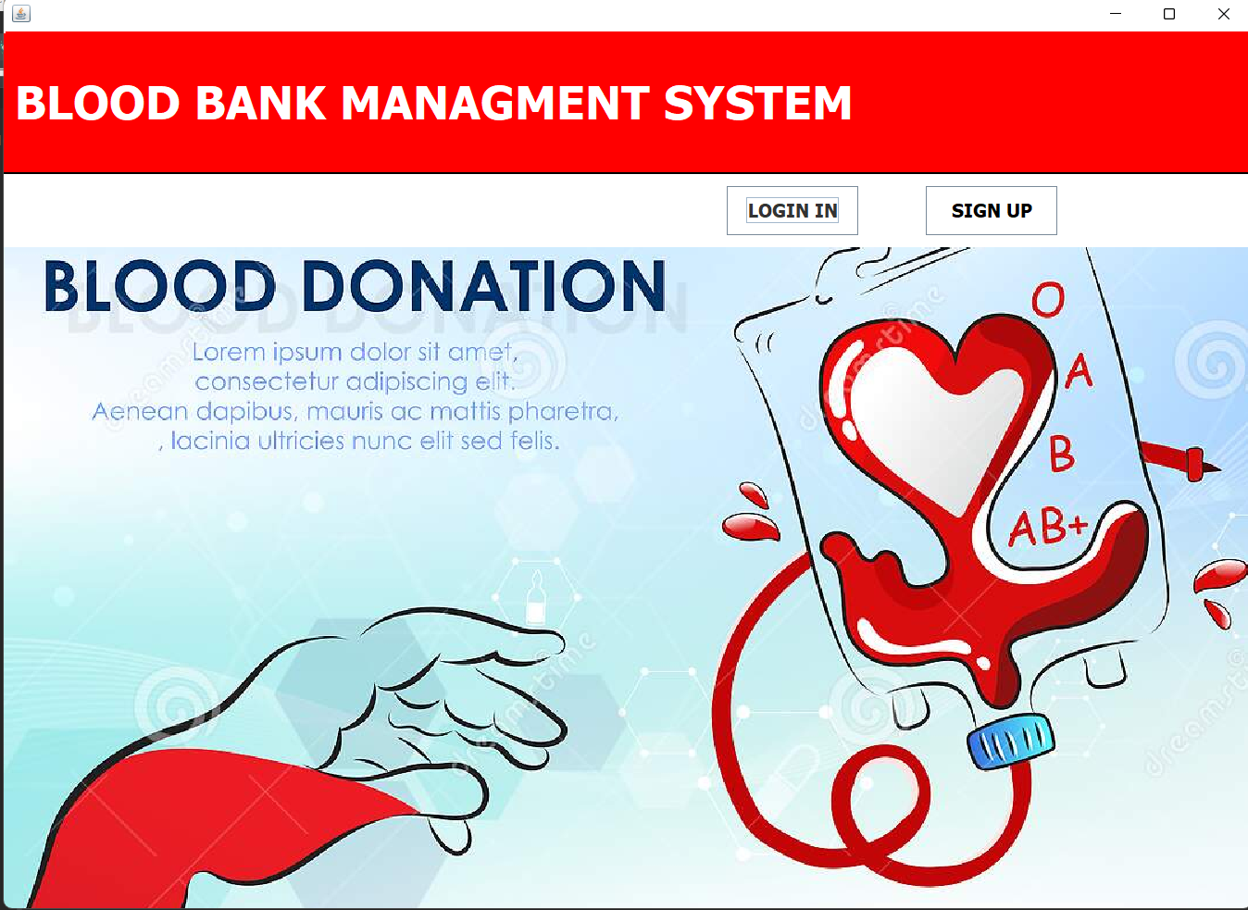

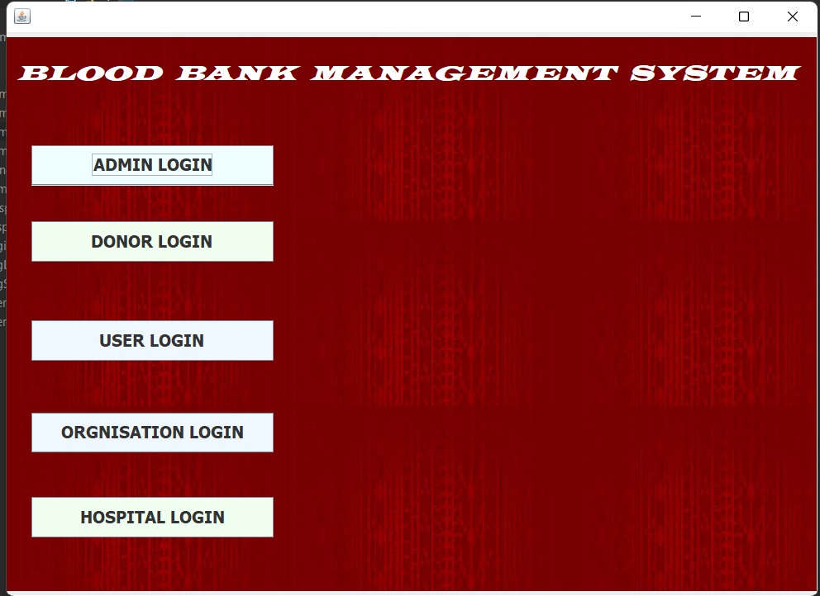

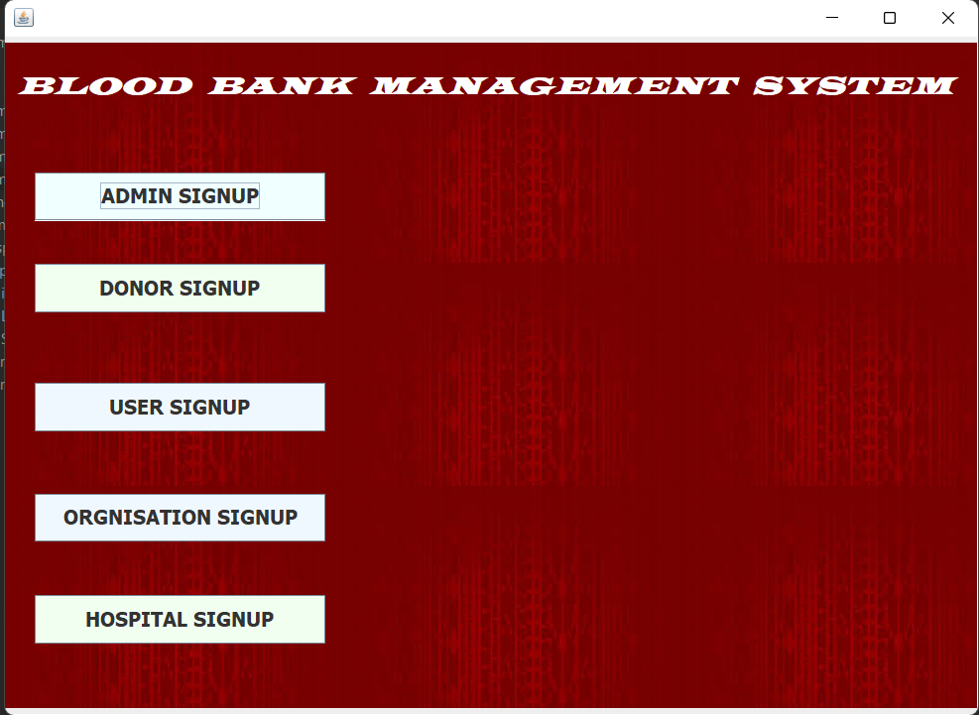

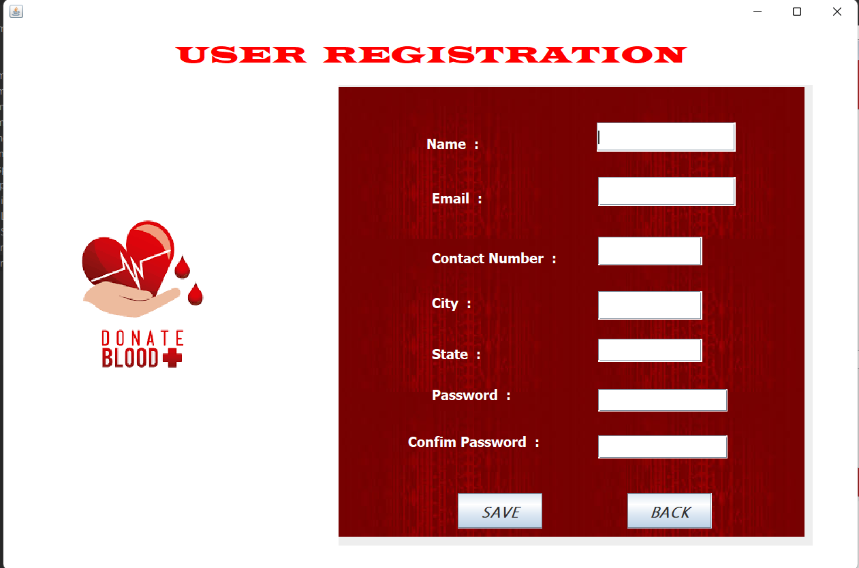

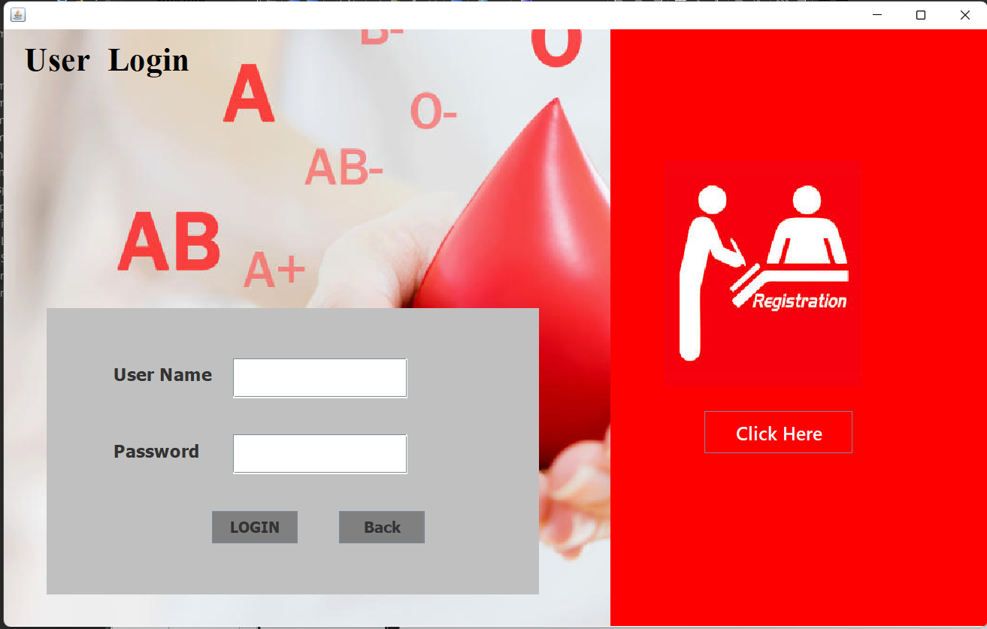

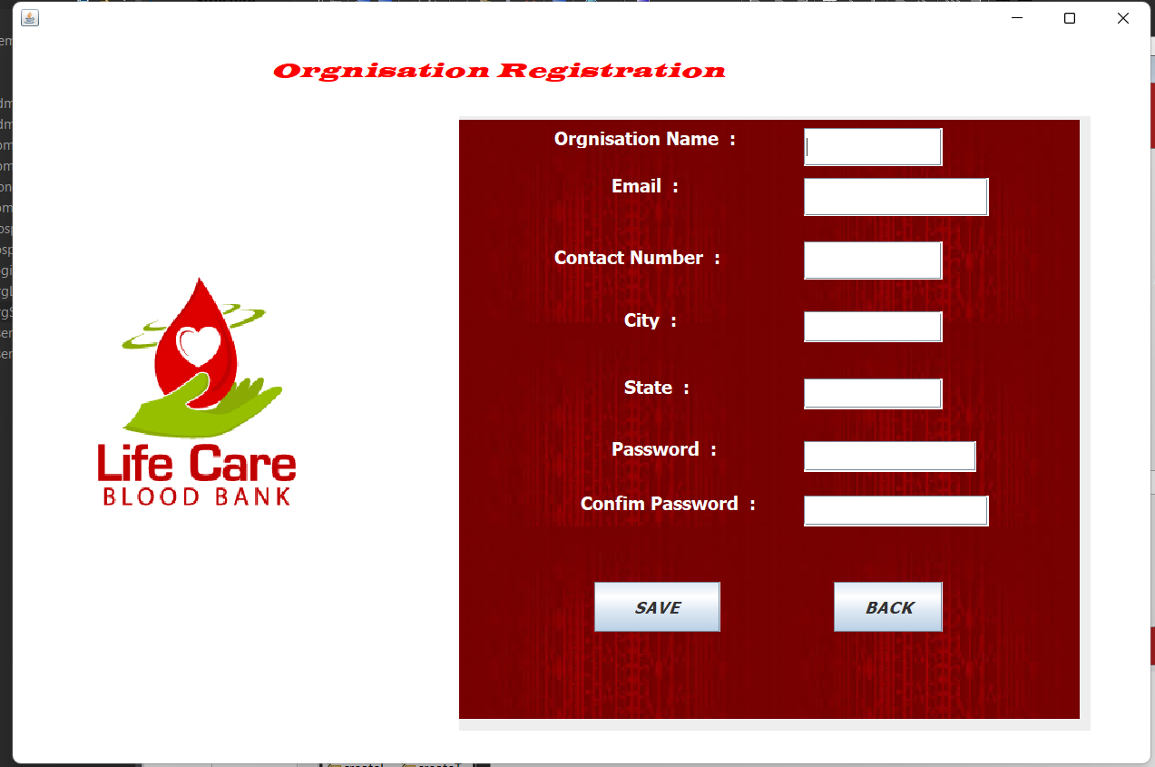

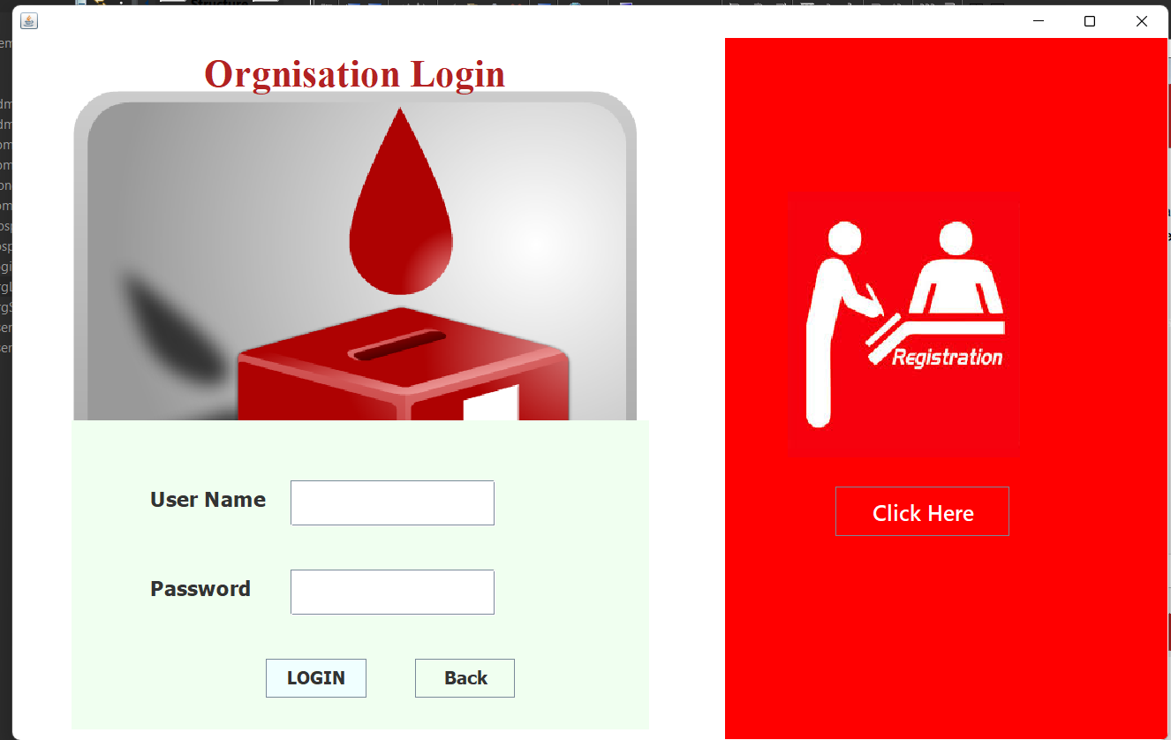

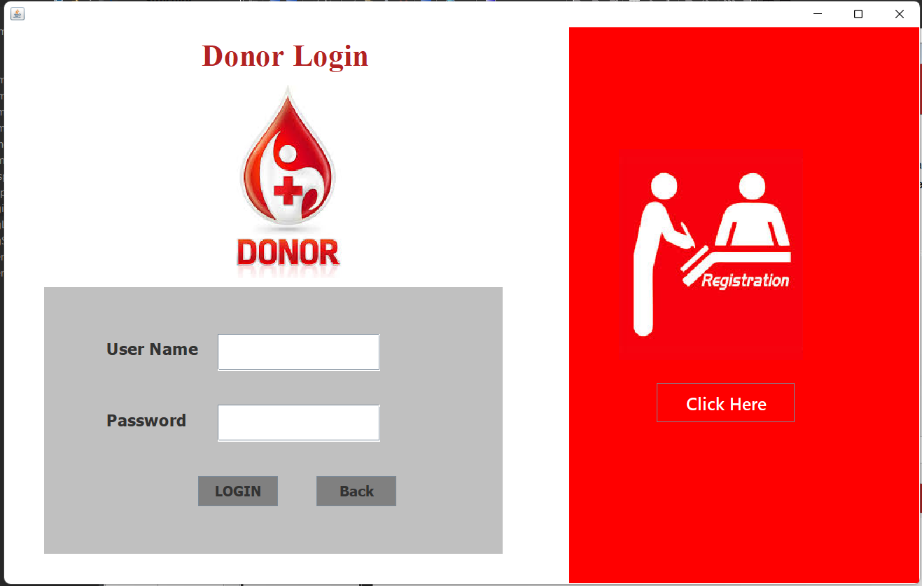

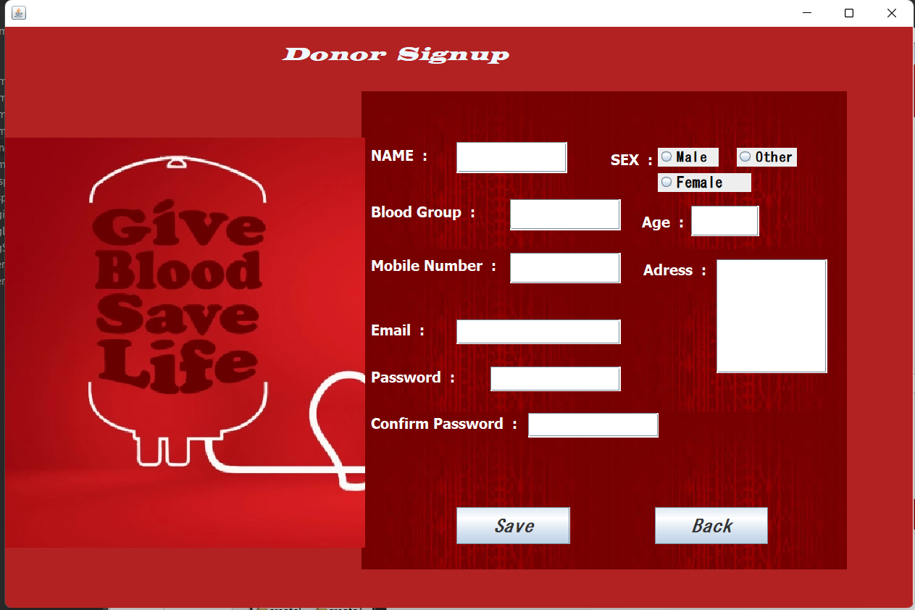

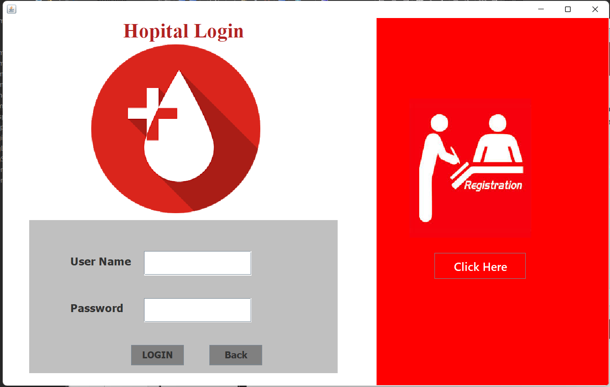

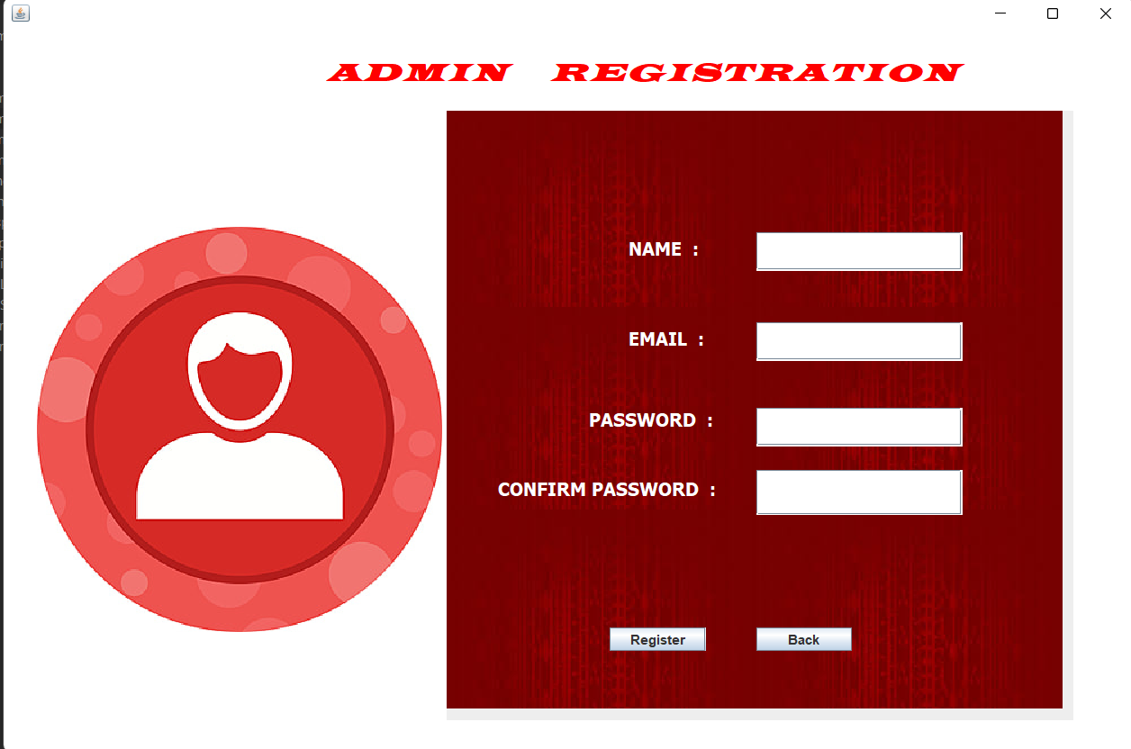

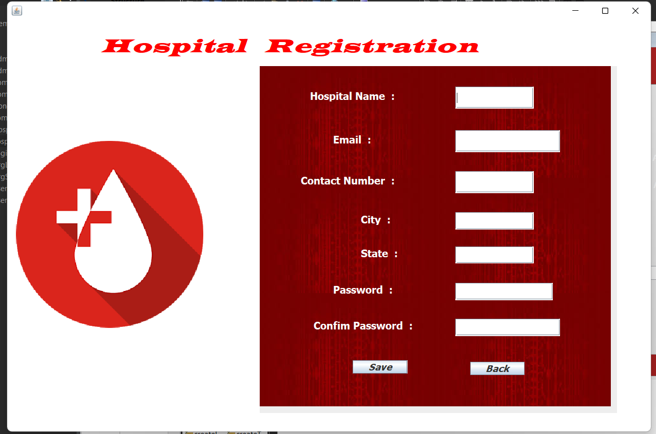

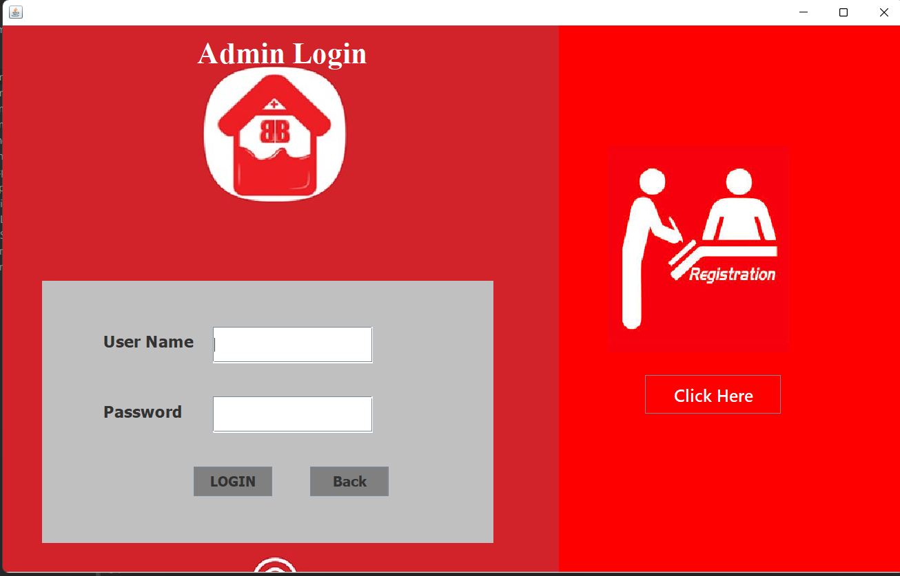

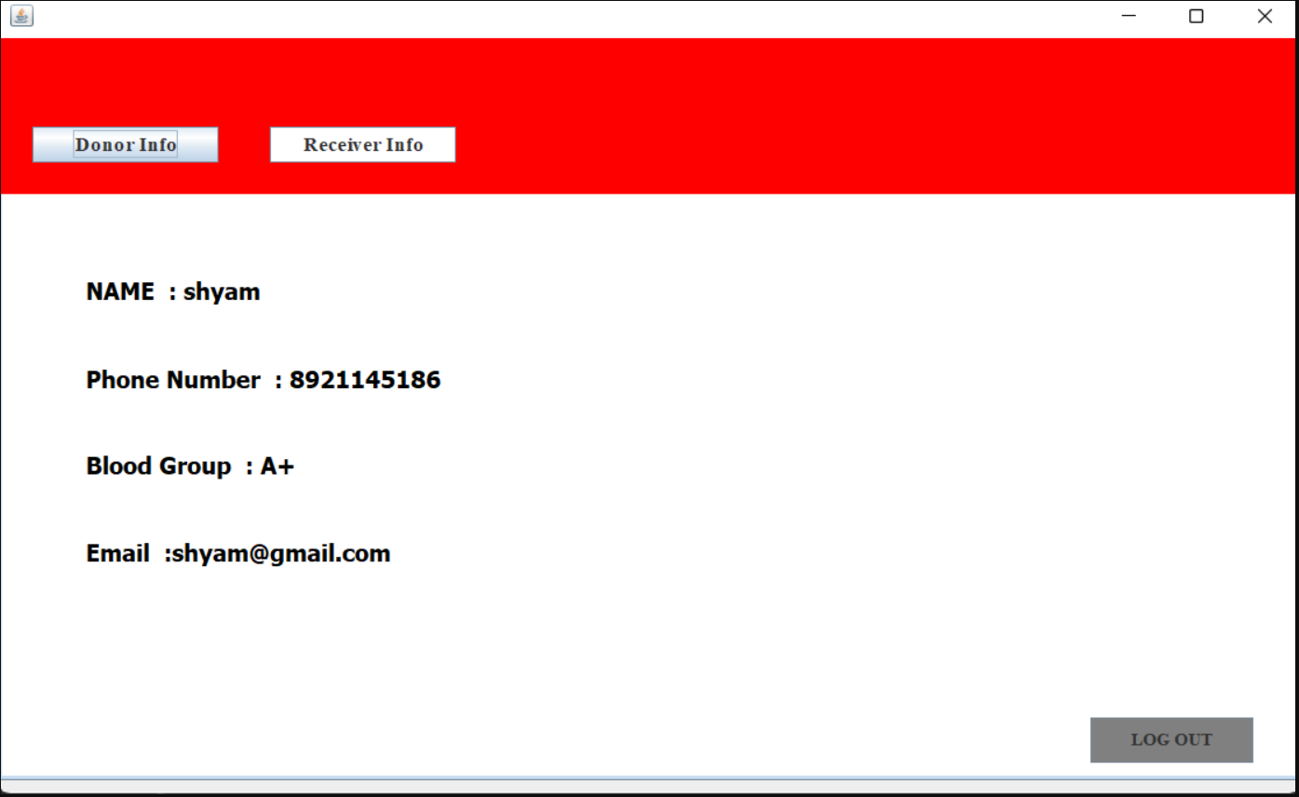

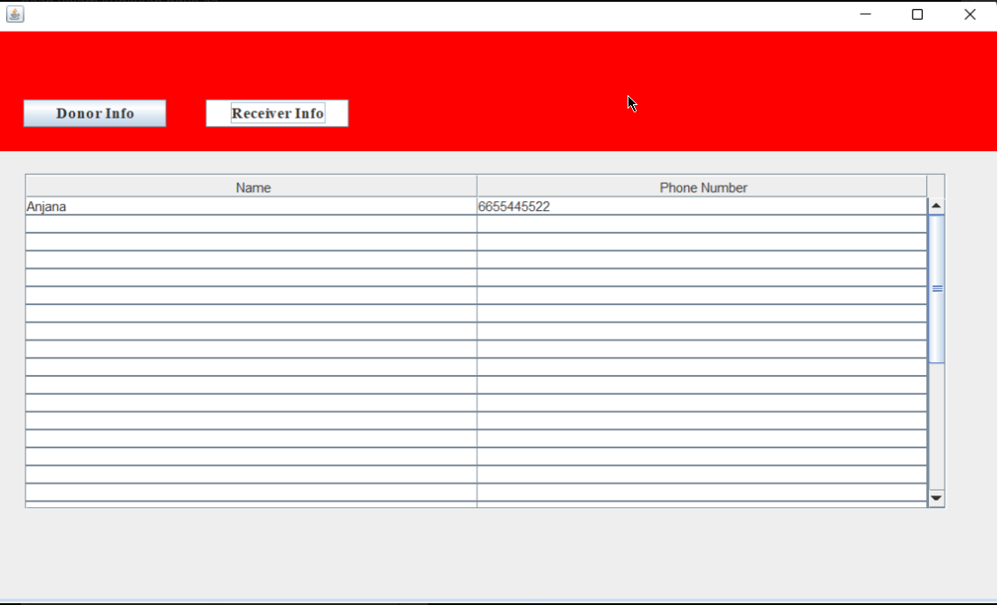

**Advantages of Blood Bank Management System**

The advantages of the blood bank donation system are:

• It is based on a Client-Server System, meaning multiple Admins can be supported.

• It operates on a minimalistic User Interface so that any user of the system can do what they need to do with almost no training and extreme ease.

• Erroneous data is not entered into the system and rendered invalid.

• Admin can automatically remove the registered donors.

**Summary**

We have developed a highly comprehensive and easy-to-use system for any small blood bank management camp. It is easy to implement and requires no training to use. It provides options for Admins. It is error-proof and does a large amount of work in the background. The blood bank donation system has the responsibility to collect blood only from donors who are at low risk for any infection that could be transmitted through transfusion and who are unlikely to jeopardize their own health by blood donation.

**\*\*\*\*\*\*\*\*\*\*\*\*\*\*\*\*\*\***